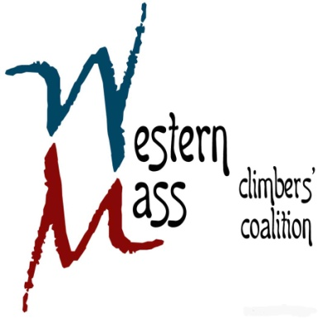

**3rd Quarterly Meeting Agenda**

**Wednesday July 30, 2014 / 6 PM / CRG Hadley**

**AMC/WMCC BBQ Recap**

* Current financials
* Membership

**Rendezvous Planning**

* Current standing
* Location/Schedule/Camping update
* Other

**Action and Outreach**

* Farley management
  + EMS support
* Current access projects
  + DCR
  + Other crag opportunities